1.Find all the information about each products:

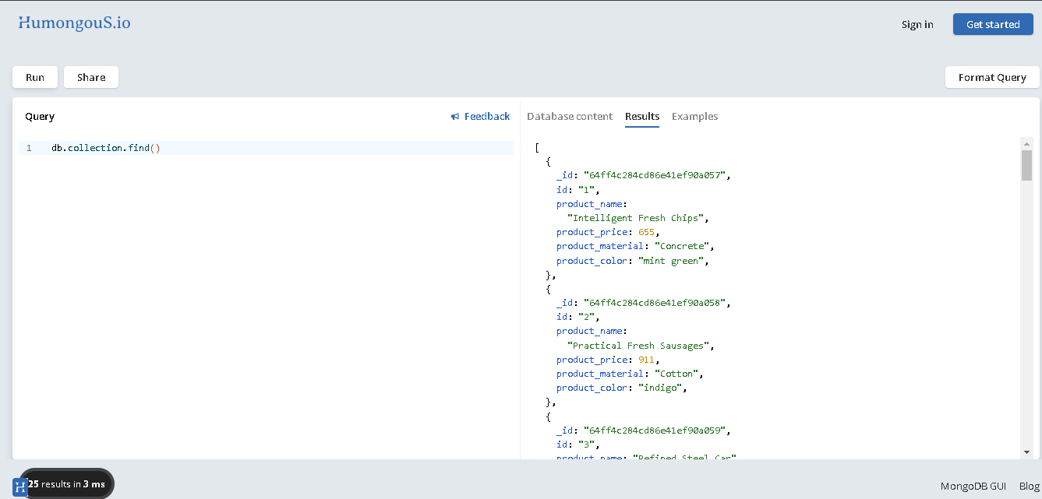

2. Find the product price which are between 400 to 800:

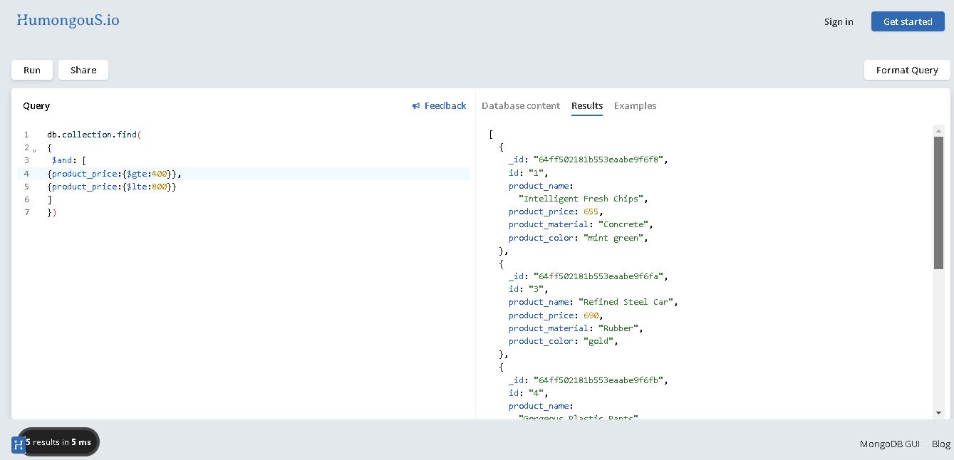

3. Find the product price which are not between 400 to 600:

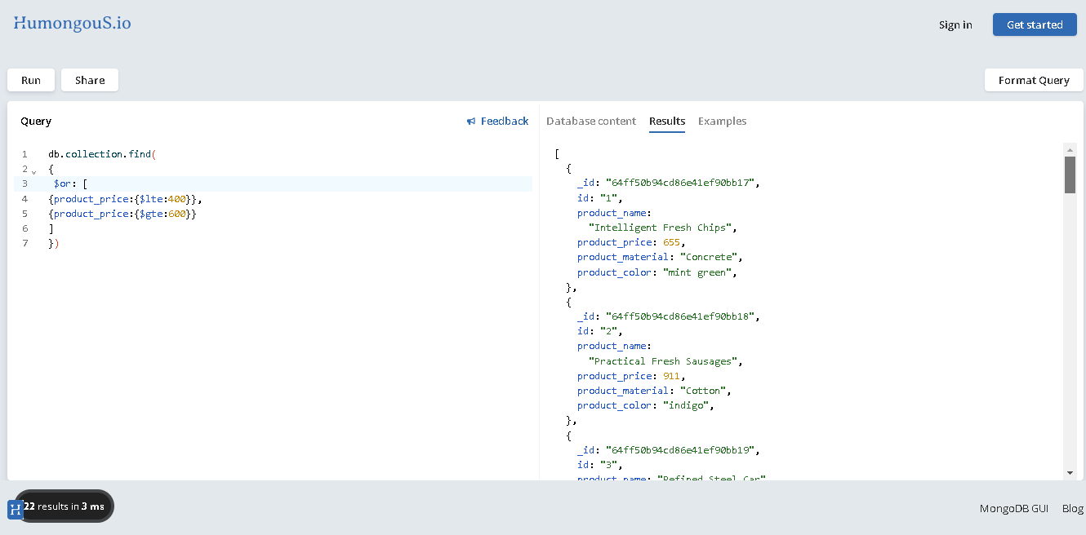

4. List the four product which are grater than 500 in price:

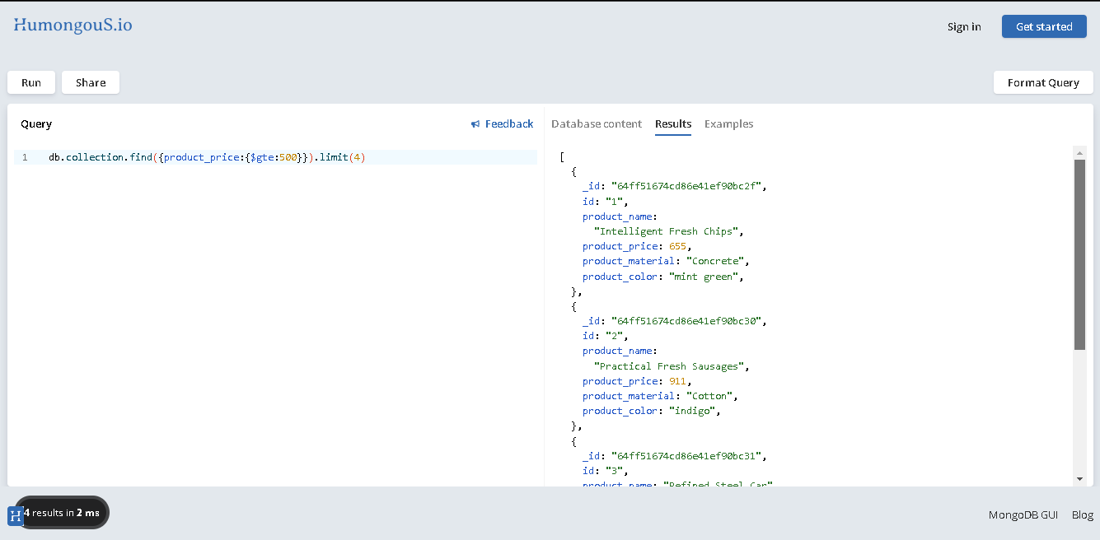

5. Find the product name and product material of each products:

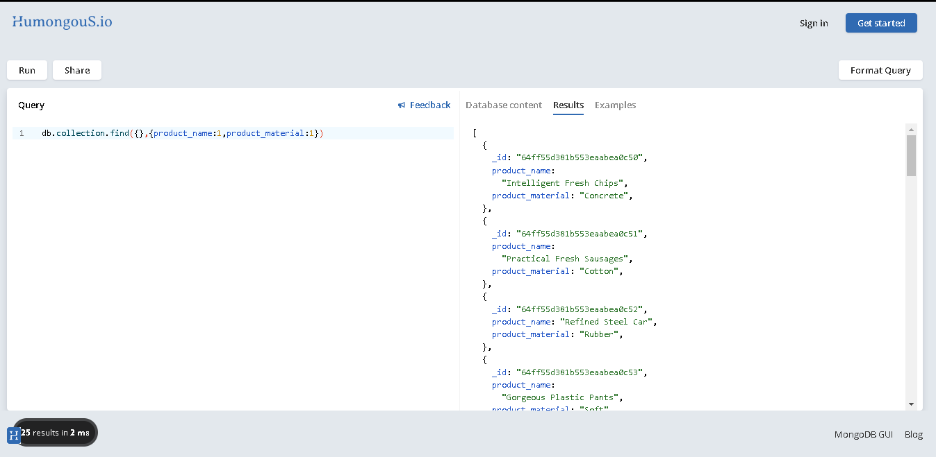

6: Find the product with a row id of 10: 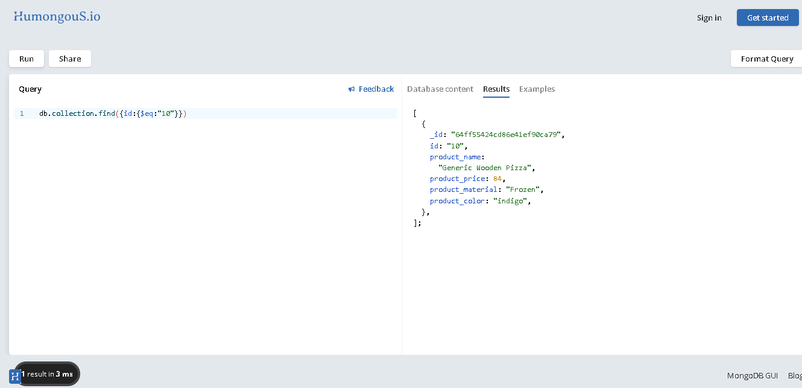

7: Find only the product name and product material:

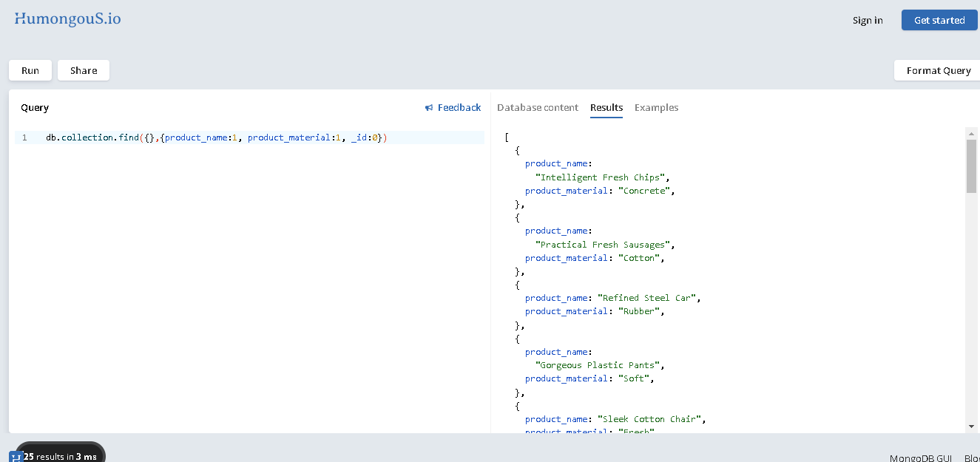

8. Find all products which contain the value of soft in product material:

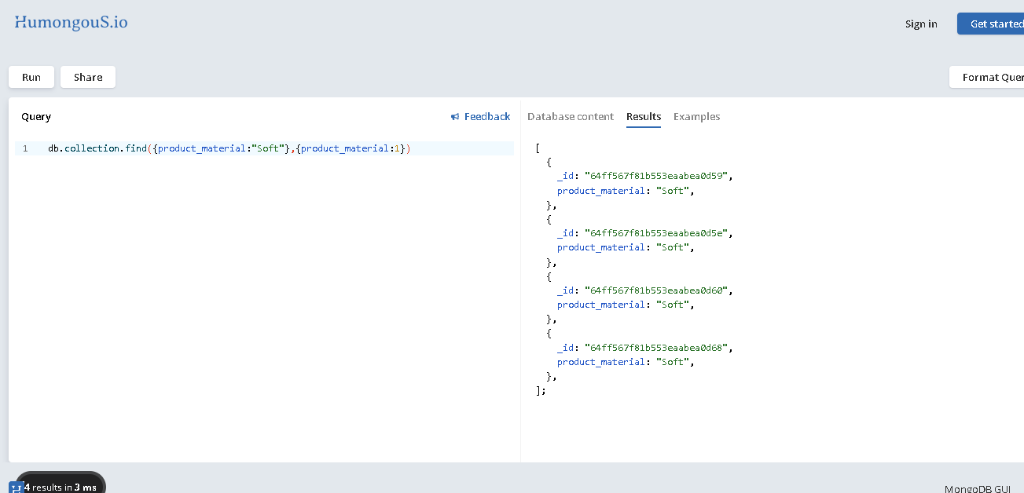

9. Find products which contain product color indigo  and product price 492.00:

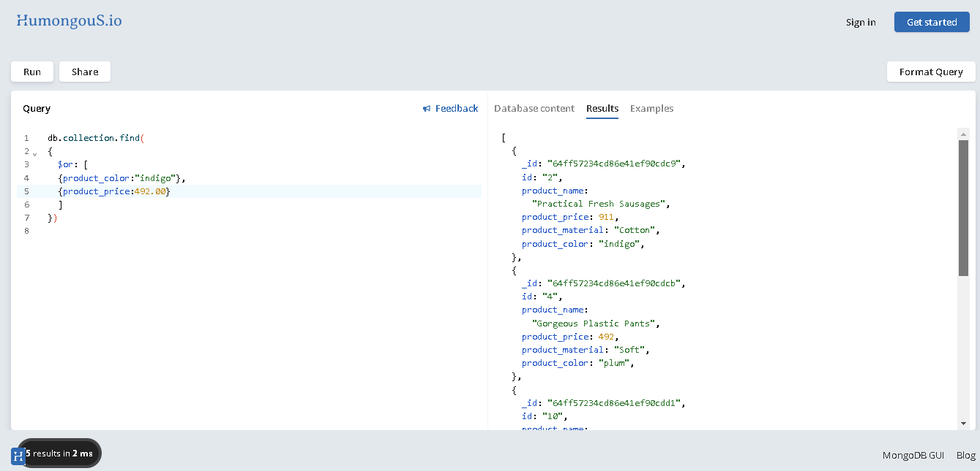

10. Delete the products which product price value are same:

